Employee Management System

RA1911003010946

SHUBHAM PAREEK

ER DIAGRAM:

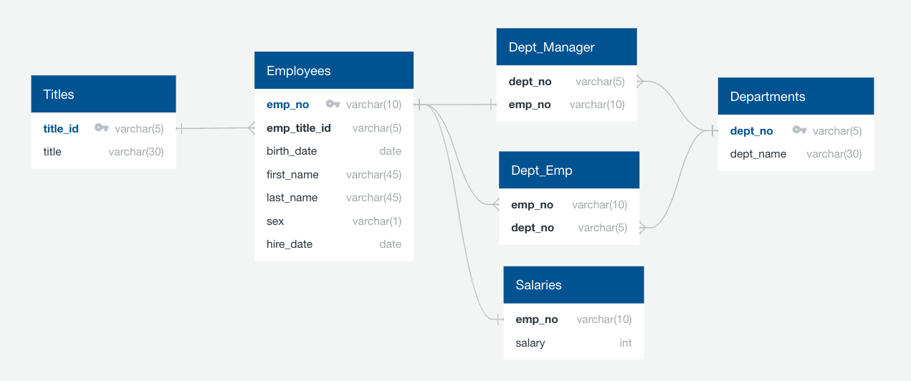

Created a table schema for each of the 6 CSV files with specific data types, primary keys, foreign keys, and constraints.

-- create titles table

CREATE TABLE titles (

title_id VARCHAR,

title VARCHAR,

PRIMARY KEY (title_id)

);

-- create departments table

CREATE TABLE departments (

dept_no VARCHAR,

dept_name VARCHAR,

PRIMARY KEY (dept_no)

);

-- create department employees table

CREATE TABLE dept_emp (

emp_no INT,

dept_no VARCHAR,

FOREIGN KEY (emp_no) REFERENCES employees (emp_no),

FOREIGN KEY (dept_no) REFERENCES departments (dept_no),

PRIMARY KEY (emp_no, dept_no)

);

-- create department managers table

CREATE TABLE dept_manager (

dept_no VARCHAR,

emp_no INT,

FOREIGN KEY (emp_no) REFERENCES employees (emp_no),

FOREIGN KEY (dept_no) REFERENCES departments (dept_no),

PRIMARY KEY (dept_no, emp_no)

);

-- create employees table

CREATE TABLE employees (

emp_no INT,

emp_title_id VARCHAR,

birth_date DATE,

first_name VARCHAR,

last_name VARCHAR,

sex VARCHAR,

hire_date DATE,

FOREIGN KEY (emp_title_id) REFERENCES titles (title_id),

PRIMARY KEY (emp_no)

);

-- create salaries table

CREATE TABLE salaries (

emp_no INT,

salary INT,

FOREIGN KEY (emp_no) REFERENCES employees (emp_no),

PRIMARY KEY (emp_no)

);

Code:

SELECT emp.emp_no as employee_number, emp.last_name, emp.first_name, emp.sex, sal.salary

FROM employees as emp

LEFT JOIN salaries as sal

ON emp.emp_no = sal.emp_no

ORDER BY emp.emp_no;

SELECT first_name, last_name, hire_date

FROM employees

WHERE hire_date BETWEEN '1986-01-01' AND '1986-12-31';

SELECT d.dept_no, d.dept_name, dm.emp_no, e.last_name, e.first_name

FROM departments d

JOIN dept_manager dm ON (d.dept_no = dm.dept_no)

JOIN employees e ON (dm.emp_no = e.emp_no);

SELECT e.emp_no, e.last_name, e.first_name, d.dept_name

FROM employees e

JOIN dept_emp de ON (e.emp_no = de.emp_no)

JOIN departments d ON (de.dept_no = d.dept_no);

SELECT e.emp_no, e.last_name, e.first_name, d.dept_name

FROM employees e

JOIN dept_emp de ON (e.emp_no = de.emp_no)

JOIN departments d ON (de.dept_no = d.dept_no)

WHERE d.dept_name = 'Sales';

SELECT e.emp_no, e.last_name, e.first_name, d.dept_name

FROM employees e

JOIN dept_emp de ON (e.emp_no = de.emp_no)

JOIN departments d ON (de.dept_no = d.dept_no)

WHERE d.dept_name = 'Sales'

OR d.dept_name = 'Development'

SELECT count(last_name) as frequency, last_name

FROM employees

GROUP BY last_name

ORDER BY COUNT(last_name) DESC;